|  |
| --- |
| **VISVESVARAYA TECHNOLOGICAL UNIVERSITY**  **“JnanaSangama”, Belgaum -590014, Karnataka.**    **LAB RECORD**  **Bio Inspired Systems (23CS5BSBIS)**  ***Submitted by***  **Sarthak Gupta (1BM22CS352)**  ***in partial fulfillment for the award of the degree of***  **BACHELOR OF ENGINEERING**  ***in***  **COMPUTER SCIENCE AND ENGINEERING**    **B.M.S. COLLEGE OF ENGINEERING**  **(Autonomous Institution under VTU)**  **BENGALURU-560019**  **Sep-2024 to Jan-2025** |

**B.M.S. College of Engineering,**

**Bull Temple Road, Bangalore 560019**

(Affiliated To Visvesvaraya Technological University, Belgaum)

**Department of Computer Science and Engineering**



**CERTIFICATE**

This is to certify that the Lab work entitled “ Bio Inspired Systems (23CS5BSBIS)” carried out by **Aashirvaad Kumar S (1BM23CS400),** who is bonafide student of **B.M.S. College of Engineering.** It is in partial fulfillment for the award of **Bachelor of Engineering in Computer Science and Engineering** of the Visvesvaraya Technological University, Belgaum. The Lab report has been approved as it satisfies the academic requirements of the above mentioned subject and the work prescribed for the said degree.

|  |  |
| --- | --- |
| Prof. Surabhi S  Assistant Professor  Department of CSE, BMSCE | Dr. Joythi S Nayak  Professor & HOD  Department of CSE, BMSCE |

**Index**

|  |  |  |  |
| --- | --- | --- | --- |
| **Sl.**  **No.** | **Date** | **Experiment Title** | **Page No.** |
| 1 | 9-10-24 | Genetic Algorithm | 1-5 |
| 2 | 16-10-24 | Ant Colony Optimization | 6-12 |
| 3 | 30-10-24 | Particle Swarm Optimization | 13-17 |
| 4 | 13-11-24 | Cuckoo Search Algorithm | 18-23 |
| 5 | 20-11-24 | Grey Wolf Optimizer | 24-28 |
| 6 | 27-11-24 | Parallel Cellular Algorithm | 29-32 |
| 7 | 4-12-24 | Gene Expression Algorithm | 33-38 |

**Github Link:**

https://github.com/ash7-g/BIS/BIS_Lab_1BM23CS400.git

**Program 1**

**Genetic Algorithm for Optimization Problems**

**Algorithm:**

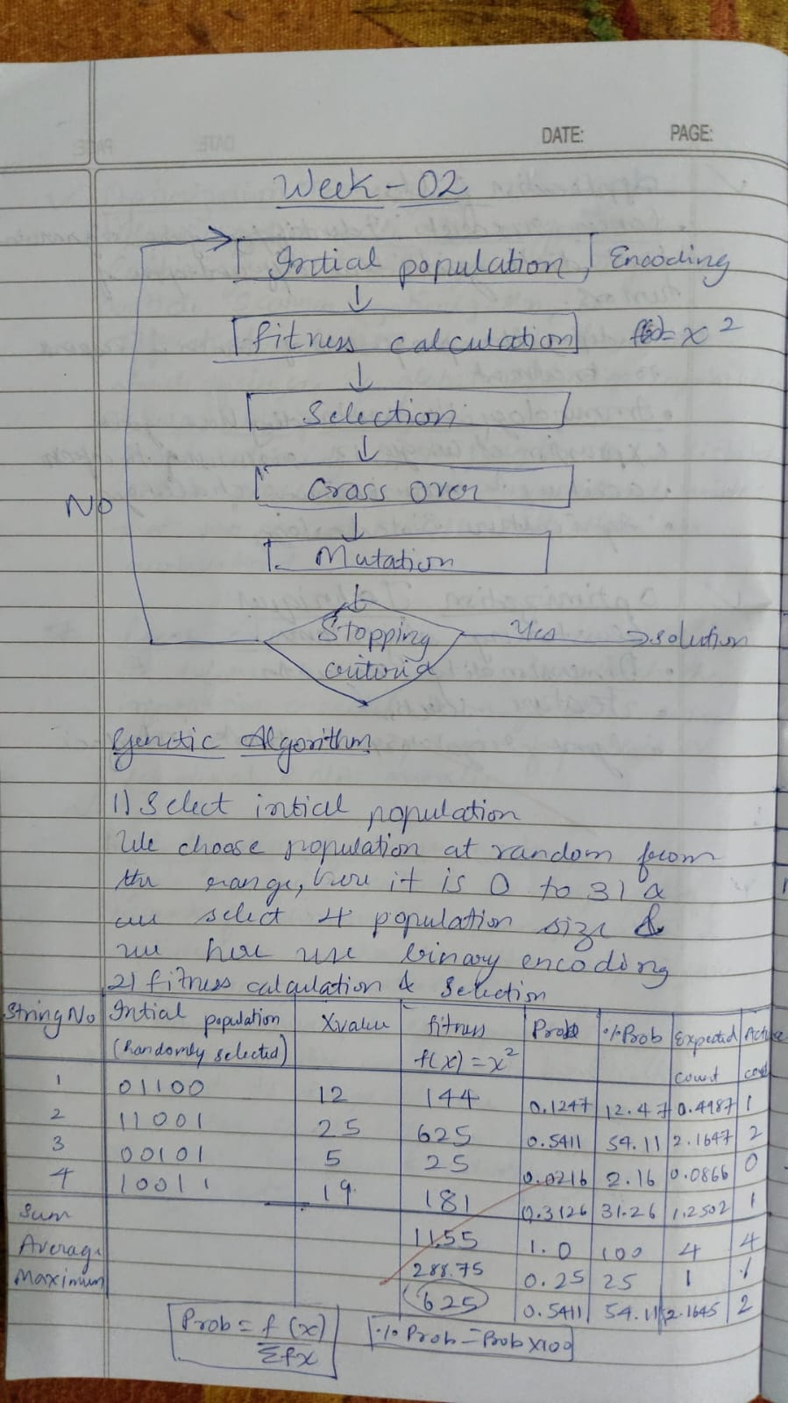

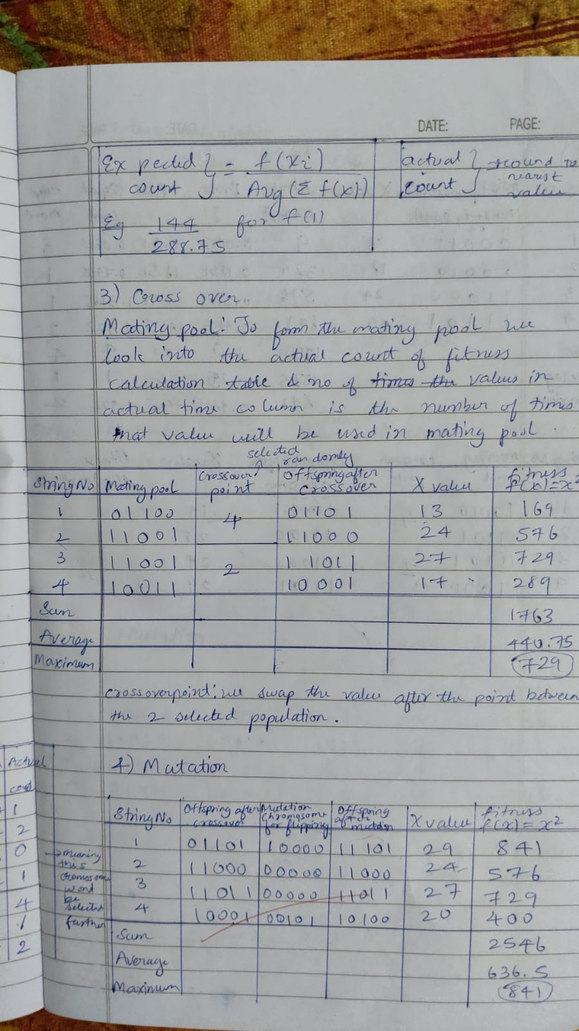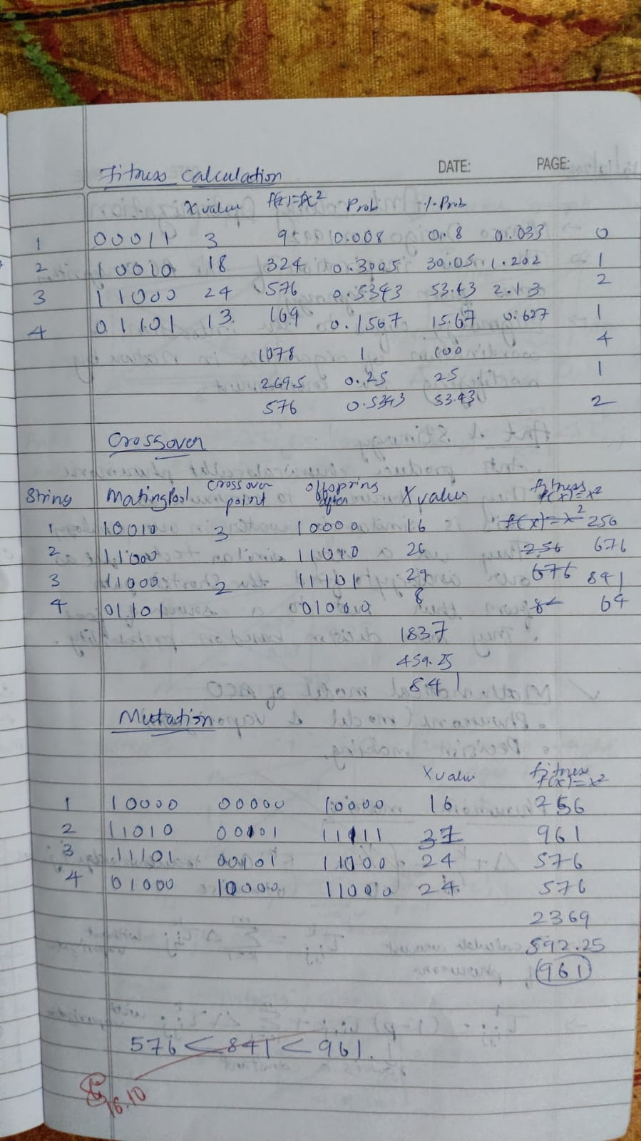

**Code:**

import random

# Set a random seed for reproducibility

random.seed(42)

def fitness(chromosome):

x = int(''.join(map(str, chromosome)), 2)

return x ** 2

def binary_string_to_chromosome(binary_string):

return [int(bit) for bit in binary_string]

def generate_population_from_input():

population = []

for _ in range(population_size):

while True:

binary_string = input("Enter a binary string of size 5 (e.g., '11001'): ")

if len(binary_string) == 5 and all(bit in '01' for bit in binary_string):

population.append(binary_string_to_chromosome(binary_string))

break

else:

print("Invalid input. Please enter a binary string of size 5.")

return population

def select_pair(population, fitnesses):

total_fitness = sum(fitnesses)

selection_probs = [f / total_fitness for f in fitnesses]

parent1 = population[random.choices(range(len(population)), selection_probs)[0]]

parent2 = population[random.choices(range(len(population)), selection_probs)[0]]

return parent1, parent2

def crossover(parent1, parent2):

point = random.randint(1, len(parent1) - 1)

offspring1 = parent1[:point] + parent2[point:]

offspring2 = parent2[:point] + parent1[point:]

return offspring1, offspring2

def mutate(chromosome, mutation_rate):

return [gene if random.random() > mutation_rate else 1 - gene for gene in chromosome]

# Parameters

population_size = 4

generations = 20

mutation_rate = 0.01

# Initialize population from user input

population = generate_population_from_input()

for generation in range(generations):

fitnesses = [fitness(chromosome) for chromosome in population]

new_population = []

# Create new population

while len(new_population) < population_size:

parent1, parent2 = select_pair(population, fitnesses)

offspring1, offspring2 = crossover(parent1, parent2)

new_population.append(mutate(offspring1, mutation_rate))

new_population.append(mutate(offspring2, mutation_rate))

# Ensure the new population has the right size

population = new_population[:population_size]

# Get the maximum fitness

fitnesses = [fitness(chromosome) for chromosome in population]

max_fitness = max(fitnesses)

print(f"Maximum Possible Fitness: {max_fitness}")

**Output:**

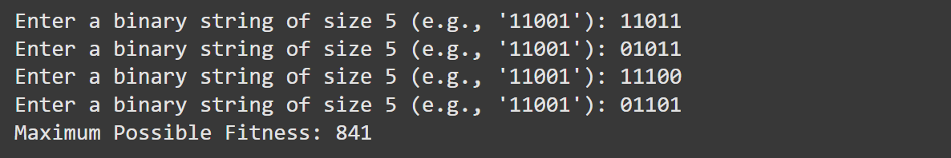

**Program 2**

**Ant Colony Optimization**

**Algorithm:**

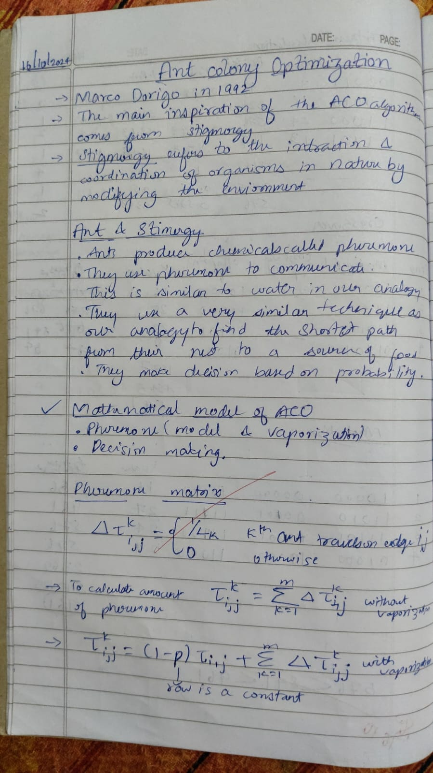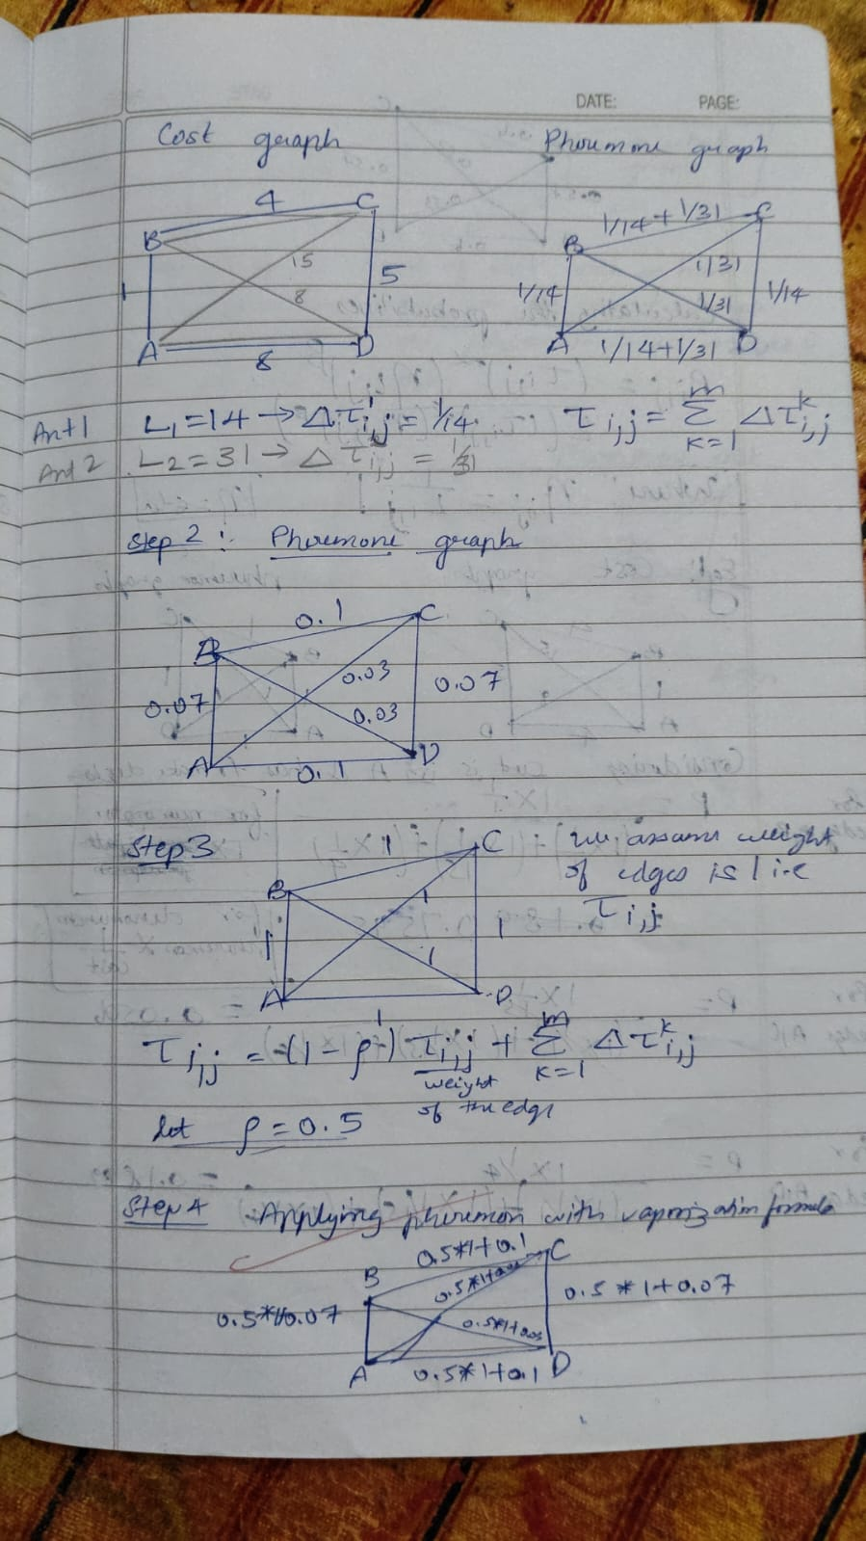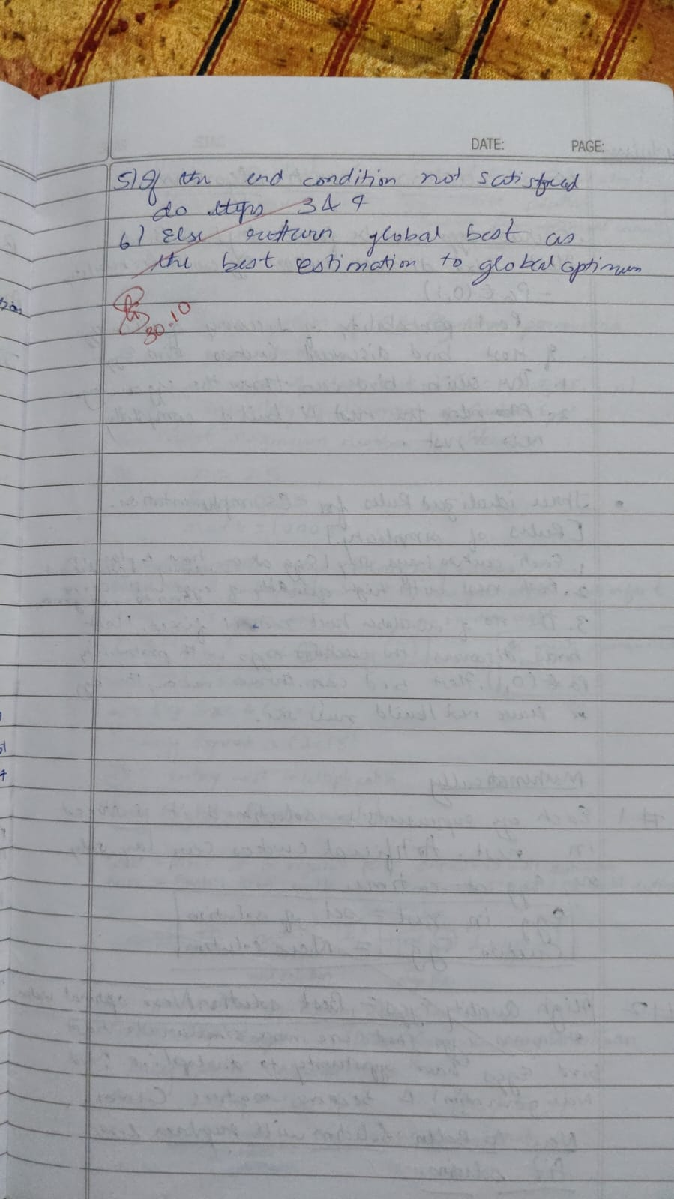

**Code:**

import random

import numpy as np

import operator

FUNCTIONS = {'+': operator.add, '-': operator.sub, '*': operator.mul, '/': operator.truediv}

TERMINALS = ['x', 1, 2, 3, 4] # x and constants

def random_gene(length=10):

return [random.choice(list(FUNCTIONS.keys()) + TERMINALS) for _ in range(length)]

def decode_chromosome(chromosome, x):

stack = []

for gene in chromosome:

if gene in FUNCTIONS: # If it's a function, pop arguments and apply

if len(stack) < 2: # Avoid errors if stack has fewer than 2 elements

stack.append(0)

continue

b = stack.pop()

a = stack.pop()

try:

result = FUNCTIONS[gene](a, b)

except ZeroDivisionError:

result = 1 # Avoid division by zero

stack.append(result)

elif gene == 'x':

stack.append(x)

else:

stack.append(gene)

return stack[0] if stack else 0 # Return top of stack as output

def fitness_function(chromosome, target_function, x_values):

predictions = [decode_chromosome(chromosome, x) for x in x_values]

targets = [target_function(x) for x in x_values]

mse = np.mean([(p - t) ** 2 for p, t in zip(predictions, targets)])

return mse

def selection(population, fitnesses):

total_fitness = sum(1 / (f + 1e-6) for f in fitnesses) # Avoid division by zero

probabilities = [(1 / (f + 1e-6)) / total_fitness for f in fitnesses]

return population[np.random.choice(len(population), p=probabilities)]

def mutate(chromosome, mutation_rate=0.1):

new_chromosome = chromosome[:]

for i in range(len(new_chromosome)):

if random.random() < mutation_rate:

new_chromosome[i] = random.choice(list(FUNCTIONS.keys()) + TERMINALS)

return new_chromosome

def crossover(parent1, parent2):

point = random.randint(1, len(parent1) - 1)

child1 = parent1[:point] + parent2[point:]

child2 = parent2[:point] + parent1[point:]

return child1, child2

def ant_colony_optimization(cost_matrix, n_ants=10, n_iterations=100, evaporation_rate=0.5, alpha=1, beta=2):

n_nodes = len(cost_matrix)

pheromones = np.ones((n_nodes, n_nodes)) # Initialize pheromones

def calculate_probability(i, j, visited):

if j in visited:

return 0

return (pheromones[i][j] ** alpha) * ((1 / cost_matrix[i][j]) ** beta)

def construct_solution():

path = [random.randint(0, n_nodes - 1)]

while len(path) < n_nodes:

i = path[-1]

probabilities = [calculate_probability(i, j, path) for j in range(n_nodes)]

total = sum(probabilities)

probabilities = [p / total if total > 0 else 0 for p in probabilities]

next_node = np.random.choice(range(n_nodes), p=probabilities)

path.append(next_node)

path.append(path[0]) # Return to start

return path

def path_cost(path):

return sum(cost_matrix[path[i]][path[i + 1]] for i in range(len(path) - 1))

best_path = None

best_cost = float('inf')

for iteration in range(n_iterations):

solutions = [construct_solution() for _ in range(n_ants)]

costs = [path_cost(solution) for solution in solutions]

for i, cost in enumerate(costs):

if cost < best_cost:

best_cost = cost

best_path = solutions[i]

pheromones *= (1 - evaporation_rate) # Evaporation

for i, solution in enumerate(solutions):

for j in range(len(solution) - 1):

pheromones[solution[j]][solution[j + 1]] += 1 / costs[i]

print(f"Iteration {iteration + 1}: Best Cost = {best_cost}")

print("Best Path:", best_path)

print("Best Cost:", best_cost)

cost_matrix = [

[0, 2, 2, 5, 7],

[2, 0, 4, 8, 2],

[2, 4, 0, 1, 3],

[5, 8, 1, 0, 2],

[7, 2, 3, 2, 0]

]

ant_colony_optimization(cost_matrix, n_ants=5, n_iterations=20)

**Output:**

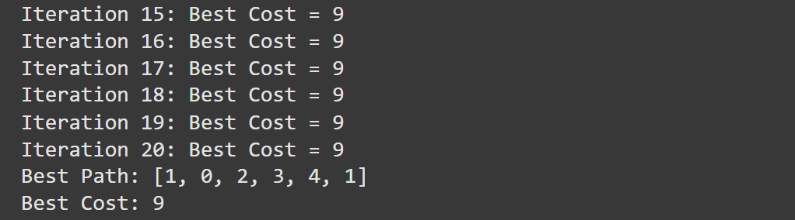

**Program 3**

**Particle Swarm Optimization**

**Algorithm:**

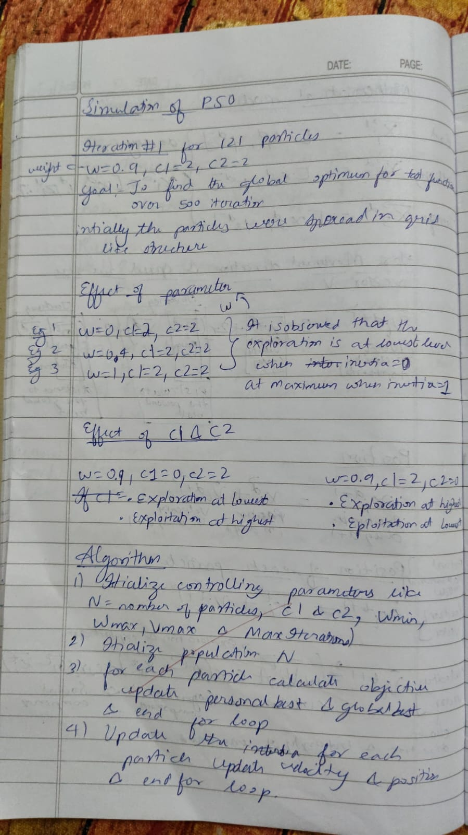

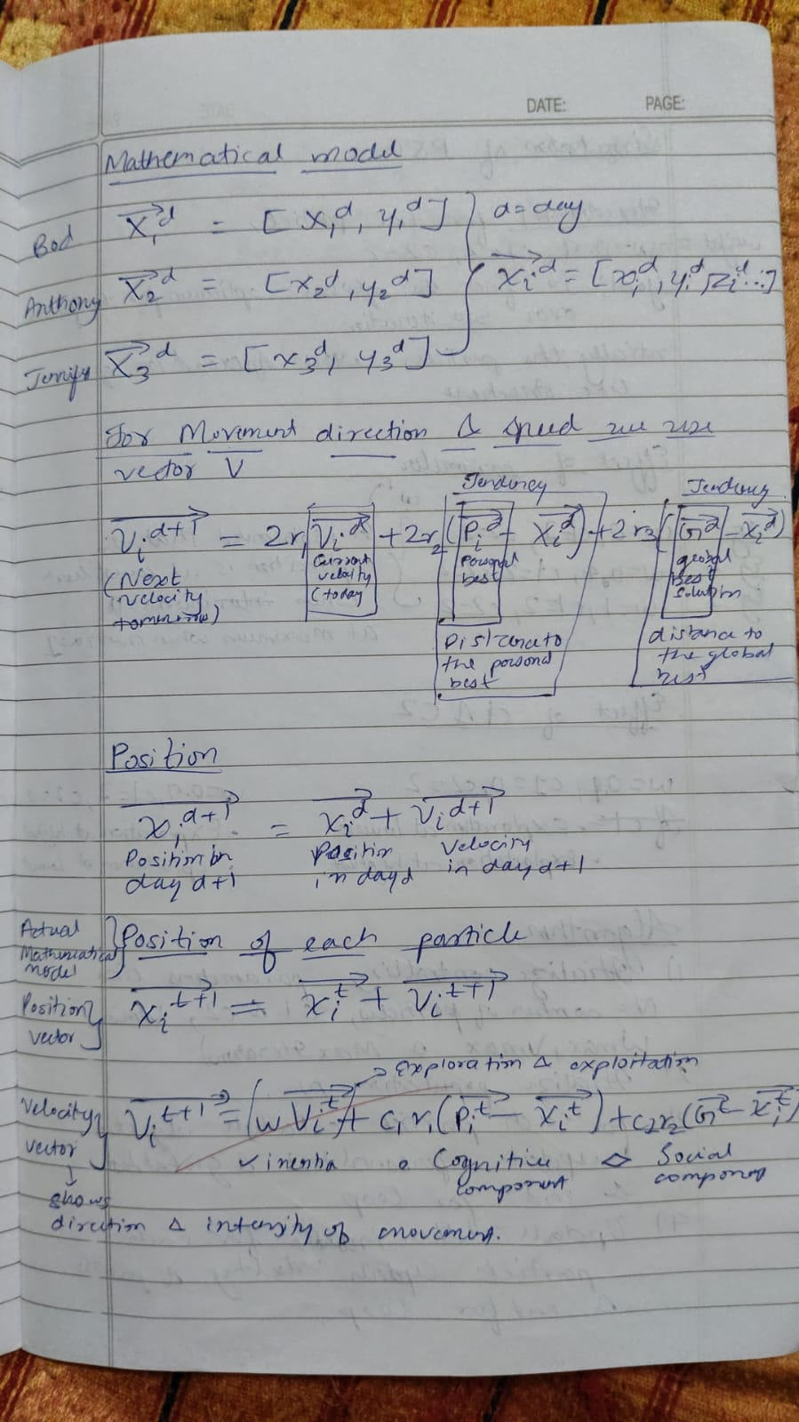

**Code:**

import random

import numpy as np

from matplotlib import pyplot as plt

from matplotlib import animation

def fitness_function(x1, x2):

f1 = x1 + 2 * -x2 + 3

f2 = 2 * x1 + x2 - 8

z = f1**2 + f2**2

return z

def update_velocity(particle, velocity, pbest, gbest, w_min=0.5, max=1.0, c=0.1):

new_velocity = np.zeros_like(particle)

r1 = random.uniform(0, max)

r2 = random.uniform(0, max)

w = random.uniform(w_min, max)

for i in range(len(particle)):

new_velocity[i] = (w * velocity[i] +

c * r1 * (pbest[i] - particle[i]) +

c * r2 * (gbest[i] - particle[i]))

return new_velocity

def update_position(particle, velocity):

new_particle = particle + velocity

return new_particle

def pso_2d(population, dimension, position_min, position_max, generation, fitness_criterion):

# Initialization

particles = np.array([[random.uniform(position_min, position_max) for _ in range(dimension)] for _ in range(population)])

pbest_position = particles.copy()

pbest_fitness = np.array([fitness_function(p[0], p[1]) for p in particles])

gbest_index = np.argmin(pbest_fitness)

gbest_position = pbest_position[gbest_index]

velocity = np.zeros((population, dimension))

images = [] # For animation

for t in range(generation):

if np.average(pbest_fitness) <= fitness_criterion:

break

for n in range(population):

velocity[n] = update_velocity(particles[n], velocity[n], pbest_position[n], gbest_position)

particles[n] = update_position(particles[n], velocity[n])

pbest_fitness = np.array([fitness_function(p[0], p[1]) for p in particles])

for n in range(population):

if pbest_fitness[n] < fitness_function(pbest_position[n][0], pbest_position[n][1]):

pbest_position[n] = particles[n]

gbest_index = np.argmin(pbest_fitness)

gbest_position = pbest_position[gbest_index]

# Plotting the current positions of the particles

fig = plt.figure(figsize=(10, 10))

ax = fig.add_subplot(111, projection='3d')

ax.set_xlabel('x')

ax.set_ylabel('y')

ax.set_zlabel('z')

x = np.linspace(position_min, position_max, 80)

y = np.linspace(position_min, position_max, 80)

X, Y = np.meshgrid(x, y)

Z = fitness_function(X, Y)

ax.plot_wireframe(X, Y, Z, color='r', linewidth=0.2)

ax.scatter3D(

particles[:, 0],

particles[:, 1],

[fitness_function(p[0], p[1]) for p in particles],

c='b'

)

# Capture the frame for animation

plt.title(f'Generation: {t + 1}')

plt.tight_layout()

plt.savefig(f'frame_{t}.png')

plt.close(fig)

# Create animation

frames = [plt.imread(f'frame_{i}.png') for i in range(t)]

fig, ax = plt.subplots(figsize=(10, 10))

ax.axis('off')

image = ax.imshow(frames[0])

def update(frame):

image.set_array(frames[frame])

return image,

ani = animation.FuncAnimation(fig, update, frames=len(frames), interval=100)

ani.save('./pso_simple.gif', writer='pillow')

# Print the results

print('Global Best Position: ', gbest_position)

print('Best Fitness Value: ', min(pbest_fitness))

print('Average Particle Best Fitness Value: ', np.average(pbest_fitness))

print('Number of Generations: ', t)

# Run the PSO algorithm

pso_2d(population=30, dimension=2, position_min=-10, position_max=10, generation=100, fitness_criterion=1e-3)

**Output:**

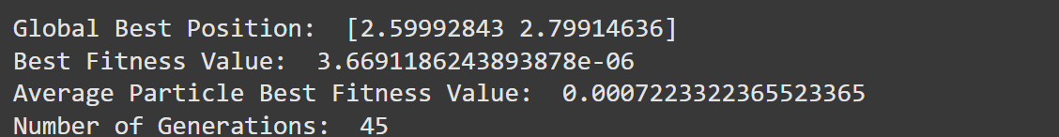

**Program 4**

**Cuckoo Search Algorithm**

**Algorithm:**

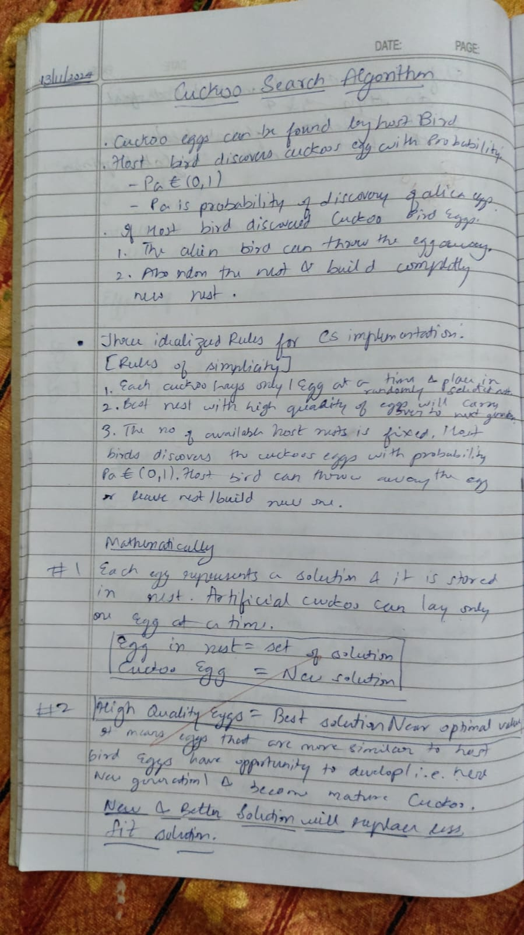

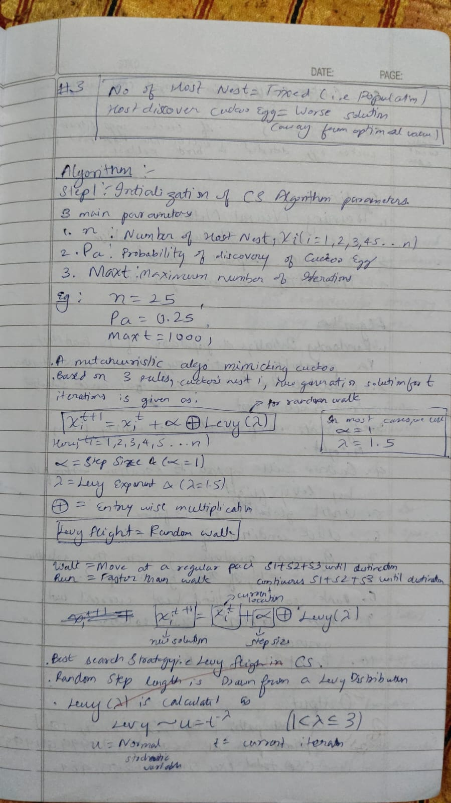

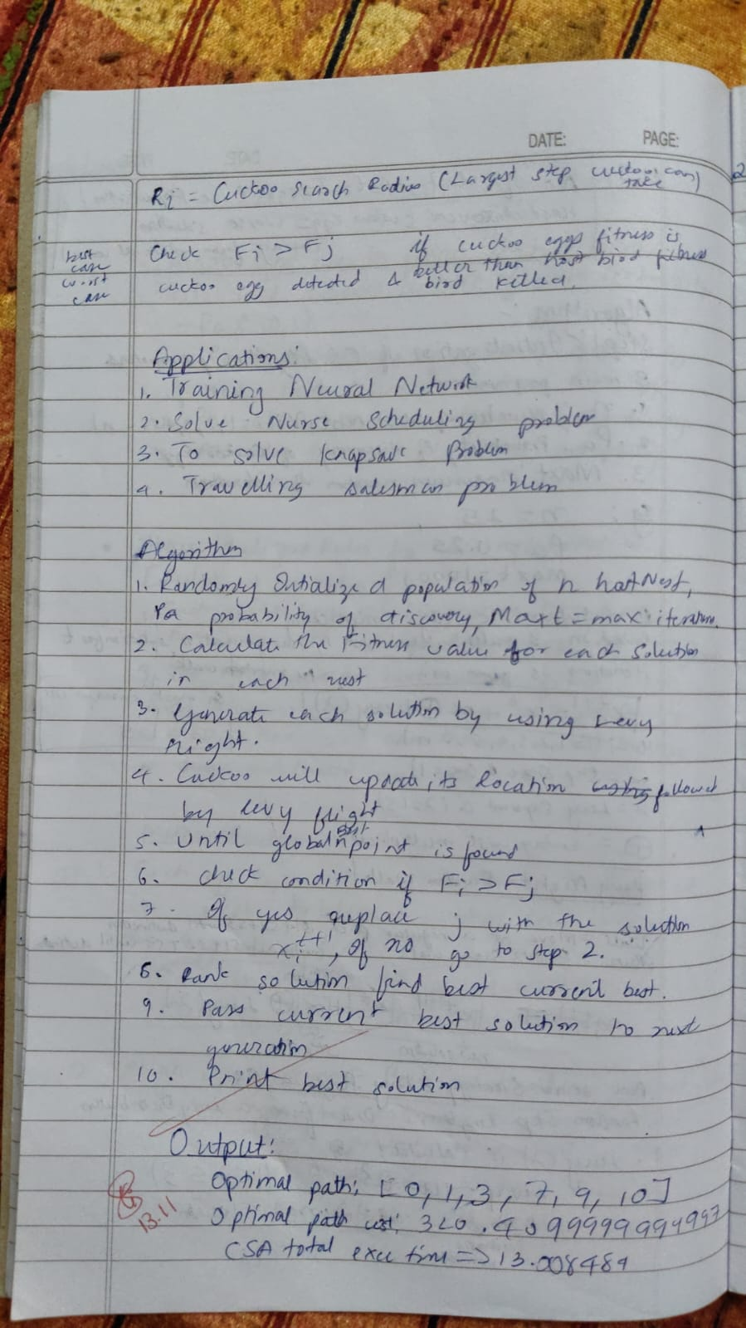**Code:**

import numpy as np

import matplotlib.pyplot as plt

# Objective function: Rastrigin Function

def rastrigin(x):

A = 10

return A * len(x) + sum(xi**2 - A * np.cos(2 * np.pi * xi) for xi in x)

# Lévy flight function for generating random steps

def levy_flight(beta=1.5, dim=2):

sigma_u = np.power(np.math.gamma(1 + beta) * np.sin(np.pi * beta / 2) / np.math.gamma((1 + beta) / 2) / np.power(2, (beta - 1) / 2), 1 / beta)

sigma_v = 1

u = np.random.normal(0, sigma_u, dim)

v = np.random.normal(0, sigma_v, dim)

return u / np.power(np.abs(v), 1 / beta)

# Cuckoo Search Algorithm

class CuckooSearch:

def __init__(self, func, dim, population_size, max_generations, pa=0.25, beta=1.5, lower_bound=-5, upper_bound=5):

self.func = func # Objective function

self.dim = dim # Dimension of the problem

self.population_size = population_size # Number of nests (solutions)

self.max_generations = max_generations # Maximum number of generations

self.pa = pa # Probability of alien eggs (nest replacement)

self.beta = beta # Lévy flight exponent

self.lower_bound = lower_bound # Lower bound of the search space

self.upper_bound = upper_bound # Upper bound of the search space

# Initialize population (nests)

self.nests = np.random.uniform(self.lower_bound, self.upper_bound, (self.population_size, self.dim))

self.fitness = np.array([self.func(nest) for nest in self.nests]) # Fitness of each nest

self.best_nest = self.nests[np.argmin(self.fitness)] # Best solution found

self.best_fitness = np.min(self.fitness) # Best fitness value

# Update nests using Lévy flights and objective function evaluations

def generate_new_nests(self):

new_nests = []

for i in range(self.population_size):

step = levy_flight(self.beta, self.dim)

new_nest = self.nests[i] + step

# Apply boundary check

new_nest = np.clip(new_nest, self.lower_bound, self.upper_bound)

new_nests.append(new_nest)

return np.array(new_nests)

# Main cuckoo search algorithm

def search(self):

history = [] # To record the best fitness values over generations

for generation in range(self.max_generations):

# Generate new nests based on Lévy flight

new_nests = self.generate_new_nests()

new_fitness = np.array([self.func(nest) for nest in new_nests])

# Replace nests with new ones if they are better

for i in range(self.population_size):

if new_fitness[i] < self.fitness[i] or np.random.rand() < self.pa:

self.nests[i] = new_nests[i]

self.fitness[i] = new_fitness[i]

# Find the best nest in the current population

current_best_fitness = np.min(self.fitness)

current_best_nest = self.nests[np.argmin(self.fitness)]

# Update the global best solution

if current_best_fitness < self.best_fitness:

self.best_fitness = current_best_fitness

self.best_nest = current_best_nest

# Record the best fitness for the current generation

history.append(self.best_fitness)

print(f"Generation {generation+1}: Best fitness = {self.best_fitness}")

return self.best_nest, self.best_fitness, history

# Analyze the Cuckoo Search Algorithm

def analyze_cuckoo_search():

# Set up parameters for Cuckoo Search

dim = 2

population_size = 50

max_generations = 100

cuckoo_search = CuckooSearch(func=rastrigin, dim=dim, population_size=population_size, max_generations=max_generations)

# Run the Cuckoo Search algorithm

best_nest, best_fitness, history = cuckoo_search.search()

# Plot the convergence curve

plt.plot(history)

plt.title("Convergence Curve of Cuckoo Search Algorithm")

plt.xlabel("Generation")

plt.ylabel("Best Fitness")

plt.show()

print(f"Best solution found: {best_nest}")

print(f"Best fitness: {best_fitness}")

# Run the analysis

analyze_cuckoo_search()

**Output:**



**Program 5**

**Grey Wolf Optimizer**

**Algorithm:**

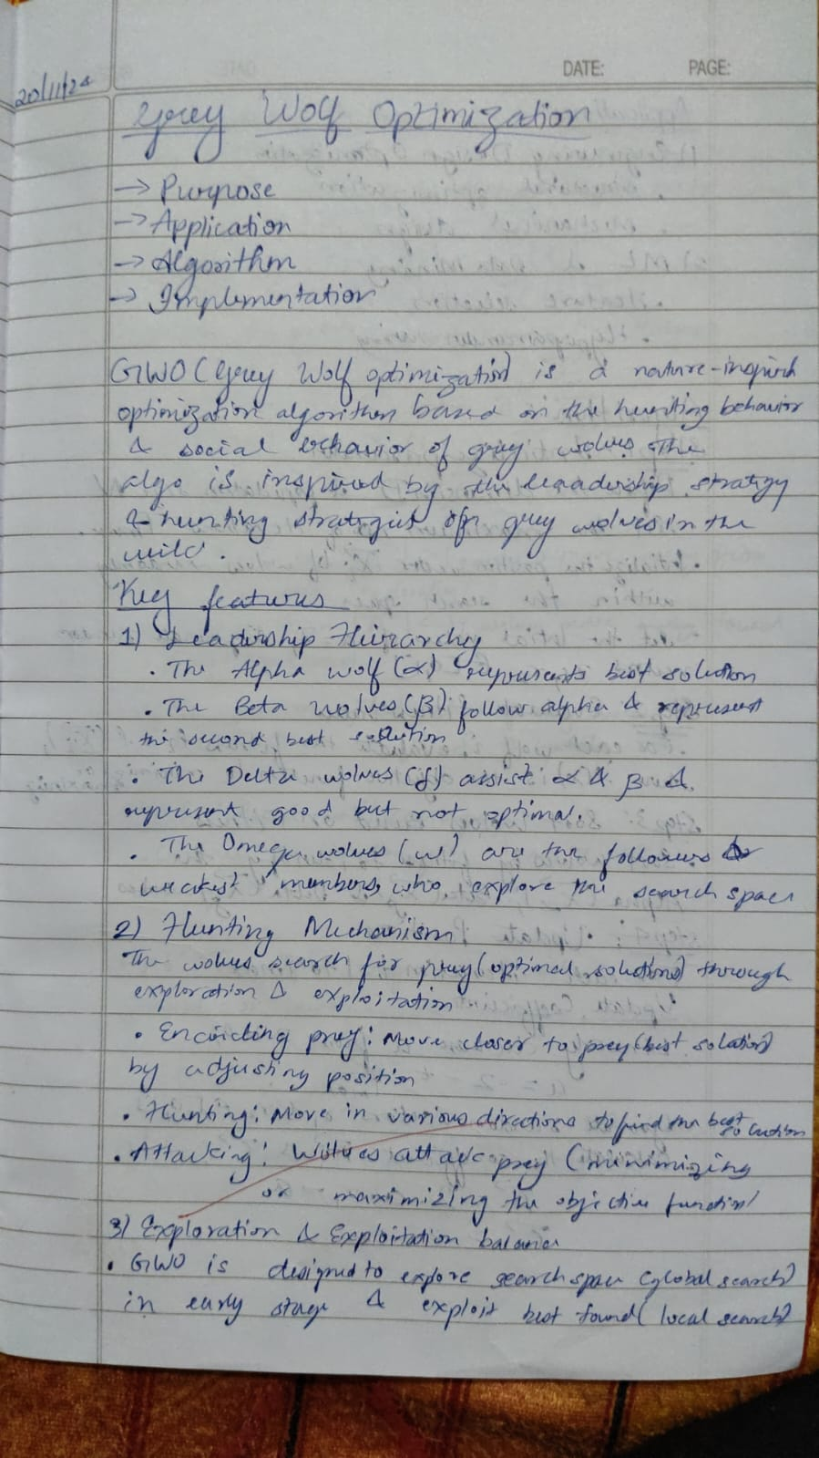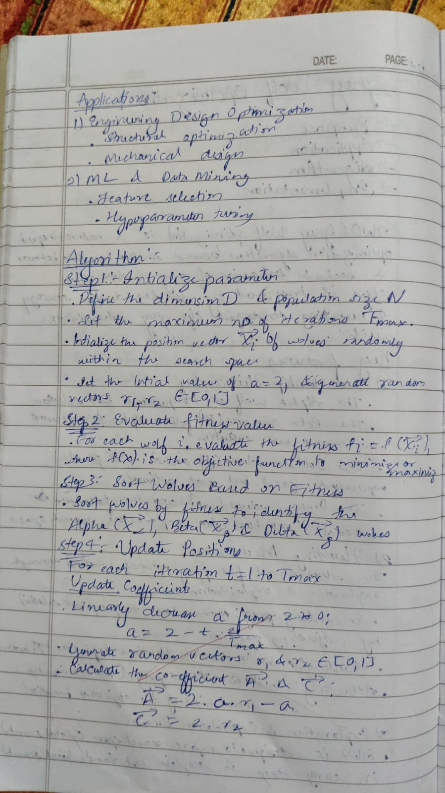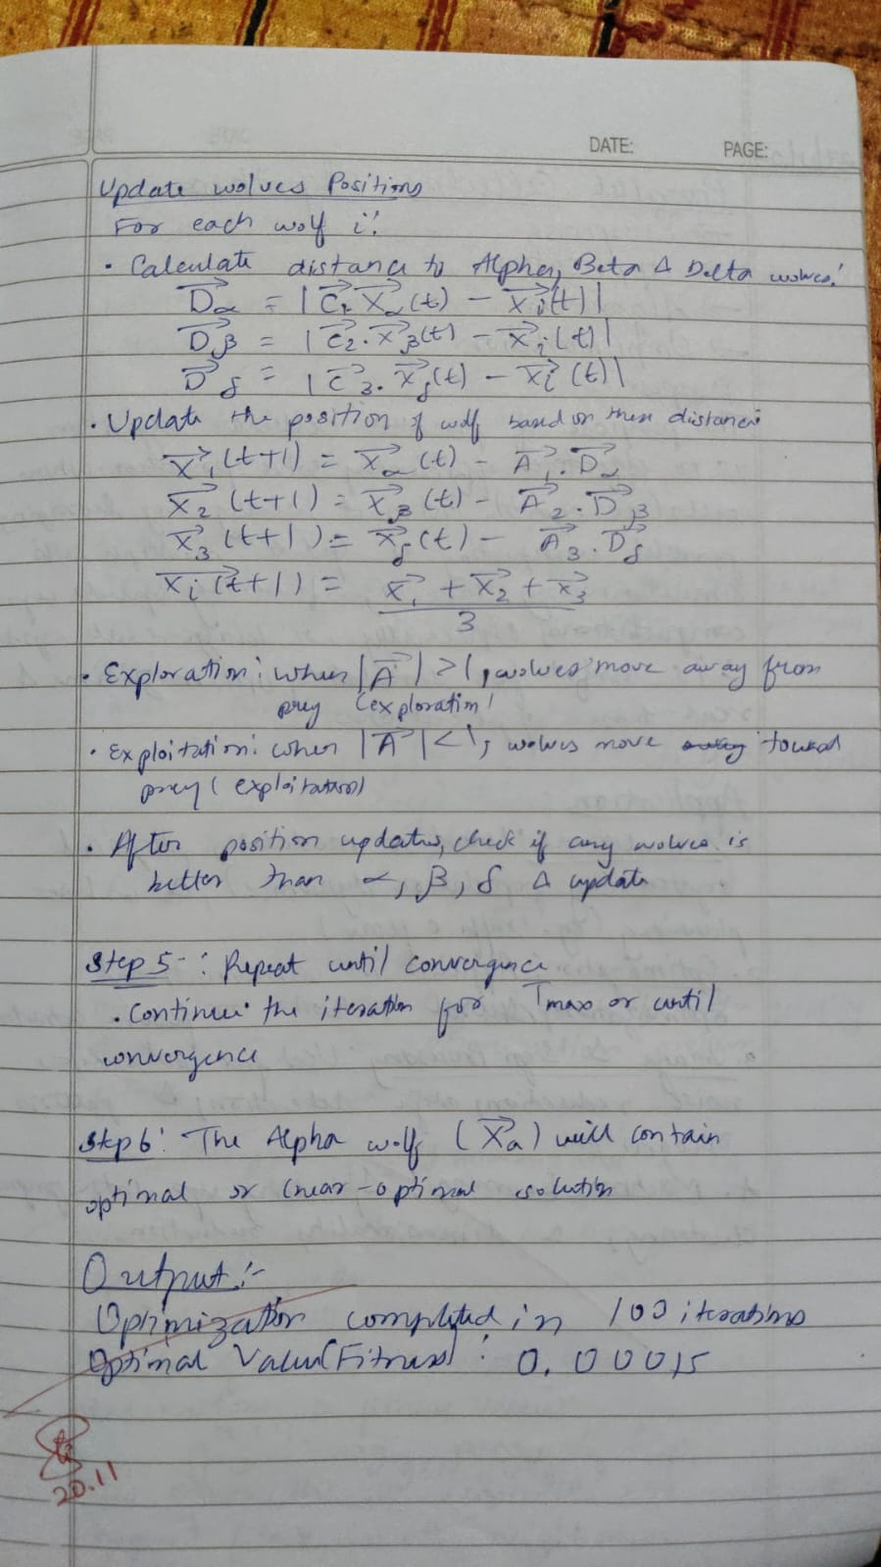

**Code:**

import numpy as np

def objective_function(x):

return np.sum(x**2)

class GreyWolfOptimizer:

def __init__(self, objective_function, n_wolves, n_variables, max_iter, lb, ub):

self.obj_func = objective_function # Objective function

self.n_wolves = n_wolves # Number of wolves

self.n_variables = n_variables # Number of variables in the problem

self.max_iter = max_iter # Maximum number of iterations

self.lb = lb # Lower bound for the search space

self.ub = ub # Upper bound for the search space

self.wolves = np.random.uniform(self.lb, self.ub, (self.n_wolves, self.n_variables))

self.alpha = np.zeros(self.n_variables)

self.beta = np.zeros(self.n_variables)

self.delta = np.zeros(self.n_variables)

self.alpha_score = float("inf")

self.beta_score = float("inf")

self.delta_score = float("inf")

def update_wolves(self):

fitness = np.apply_along_axis(self.obj_func, 1, self.wolves)

sorted_indices = np.argsort(fitness)

self.wolves = self.wolves[sorted_indices]

fitness = fitness[sorted_indices]

# Update alpha, beta, and delta wolves

self.alpha = self.wolves[0]

self.beta = self.wolves[1]

self.delta = self.wolves[2]

self.alpha_score = fitness[0]

self.beta_score = fitness[1]

self.delta_score = fitness[2]

def optimize(self):

for t in range(self.max_iter):

A = 2 * np.random.random((self.n_wolves, self.n_variables)) - 1 # Random values for exploration

C = 2 * np.random.random((self.n_wolves, self.n_variables)) # Random values for exploitation

for i in range(self.n_wolves):

D_alpha = np.abs(C[i] * self.alpha - self.wolves[i]) # Distance to alpha wolf

D_beta = np.abs(C[i] * self.beta - self.wolves[i]) # Distance to beta wolf

D_delta = np.abs(C[i] * self.delta - self.wolves[i]) # Distance to delta wolf

self.wolves[i] = self.alpha - A[i] * D_alpha

self.wolves[i] = np.clip(self.wolves[i], self.lb, self.ub)

self.update_wolves()

print(f"Iteration {t+1}/{self.max_iter}, Best Score: {self.alpha_score}")

return self.alpha, self.alpha_score # Return the best solution found

n_wolves = 30 # Number of wolves

n_variables = 5 # Number of decision variables

max_iter = 100 # Maximum number of iterations

lb = -10 # Lower bound of the search space

ub = 10 # Upper bound of the search space

gwo = GreyWolfOptimizer(objective_function, n_wolves, n_variables, max_iter, lb, ub)

best_solution, best_score = gwo.optimize()

print("Best Solution Found:", best_solution)

print("Best Score:", best_score)

**Output:**

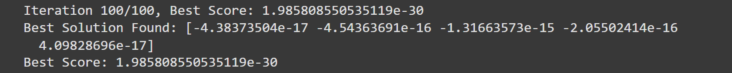

**Program 6**

**Parallel Cellular Algorithm**

**Algorithm:**

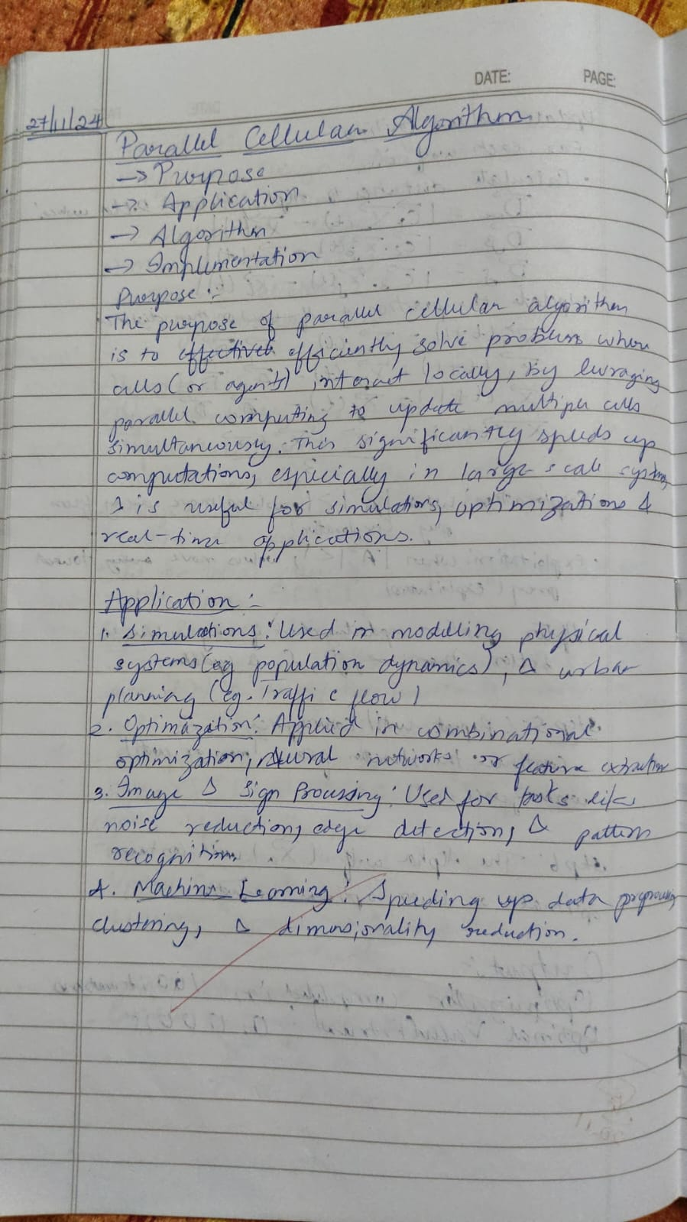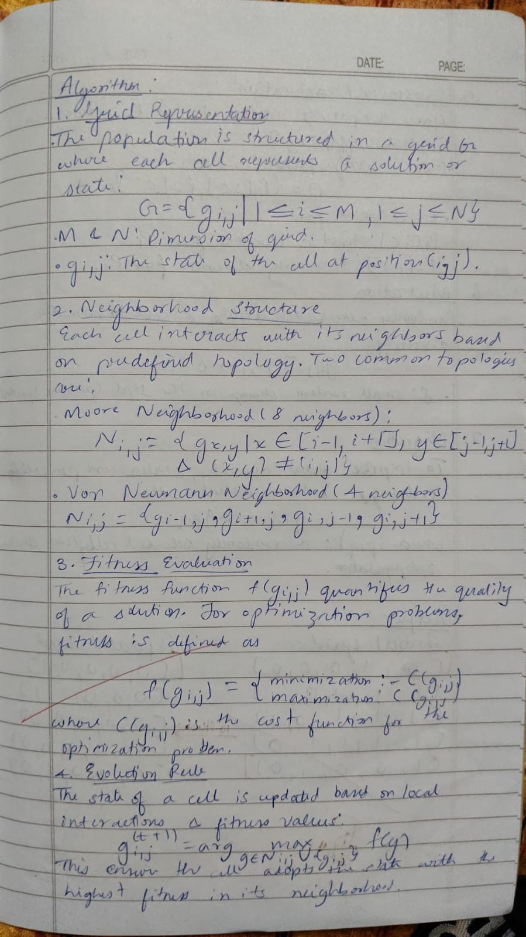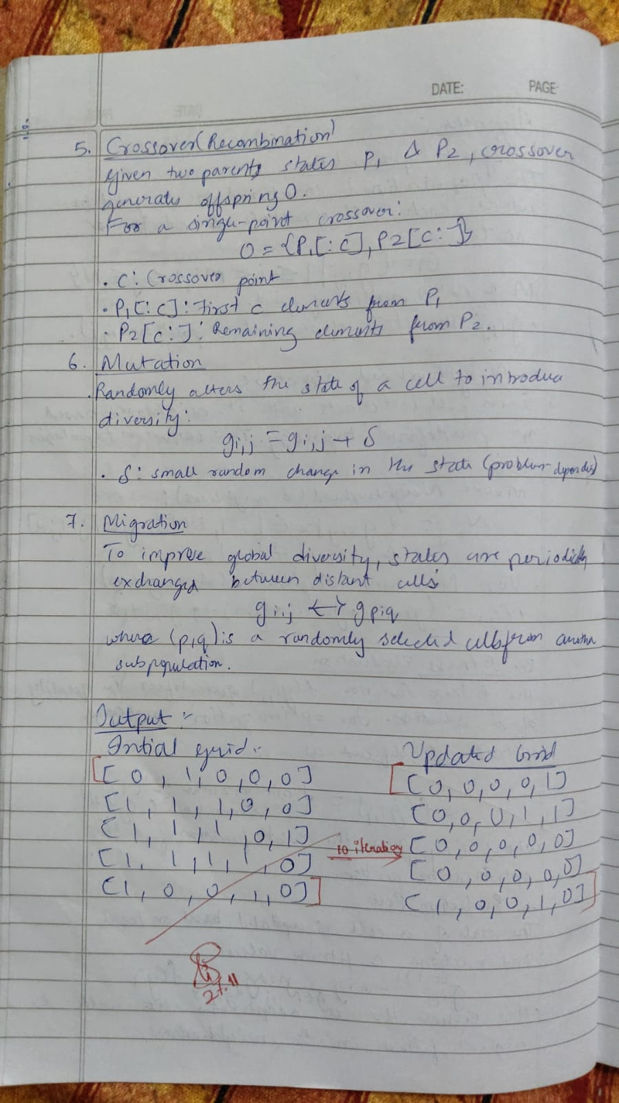

**Code:**

import numpy as np

from multiprocessing import Pool

def update_cell(cell_index, grid, size):

x, y = cell_index

neighbors = [

((x-1) % size, y), ((x+1) % size, y),

(x, (y-1) % size), (x, (y+1) % size)

]

new_state = sum(grid[n[0], n[1]] for n in neighbors) % 2 # example: majority rule

return (x, y, new_state)

def parallel_update(grid, size, num_iterations):

pool = Pool(processes=4)

for iteration in range(num_iterations):

print(f"Iteration {iteration + 1}:")

indices = [(x, y) for x in range(size) for y in range(size)]

result = pool.starmap(update_cell, [(i, grid, size) for i in indices])

for x, y, new_state in result:

grid[x, y] = new_state

print(grid)

return grid

grid_size = 10

grid = np.random.randint(2, size=(grid_size, grid_size))

print("Initial state:")

print(grid)

num_iterations = 2

updated_grid = parallel_update(grid, grid_size, num_iterations)

**Output:**

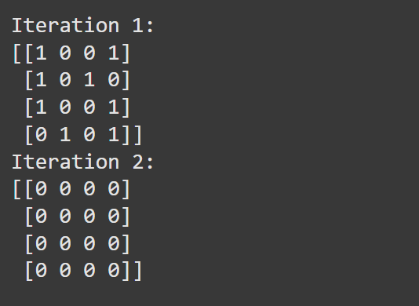

**Program 7**

**Gene Expression Algorithm**

**Algorithm:**

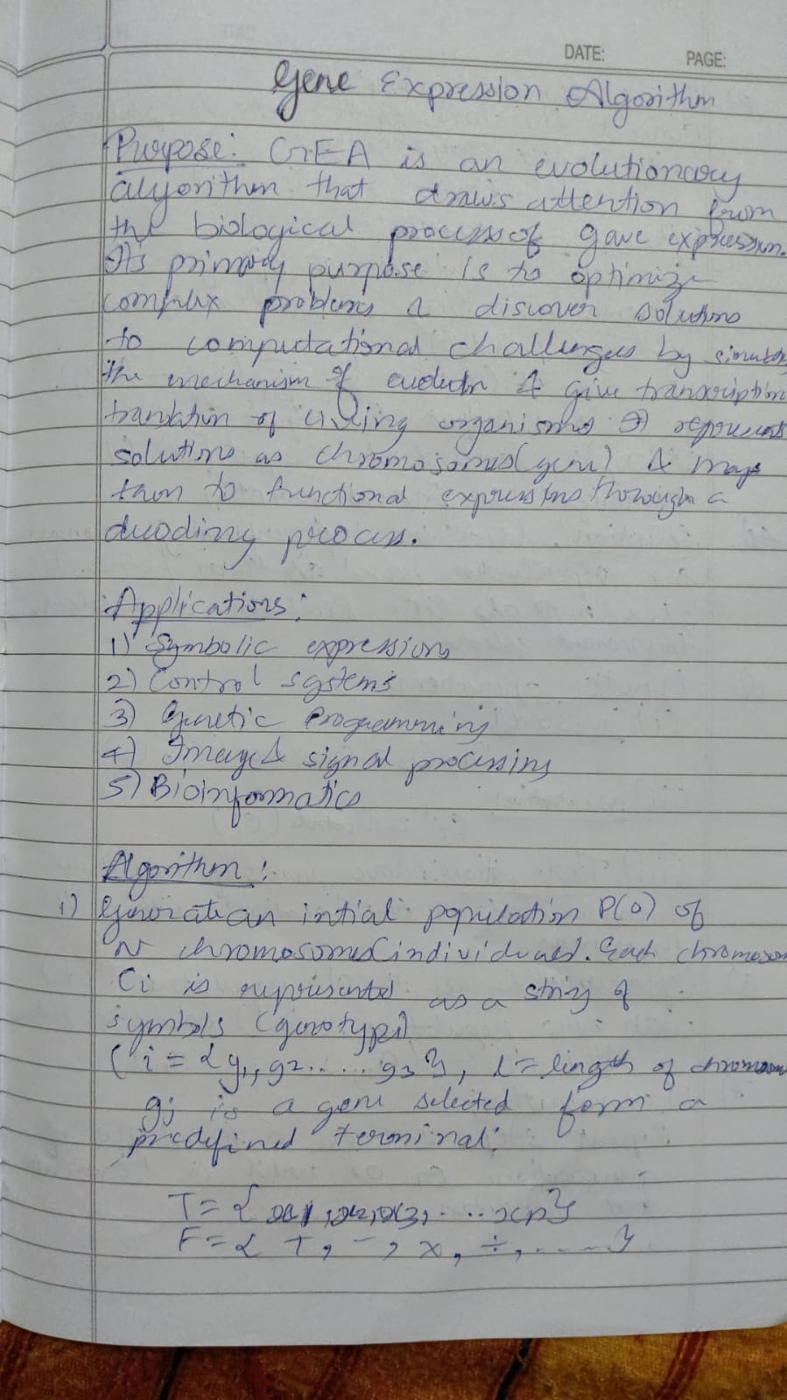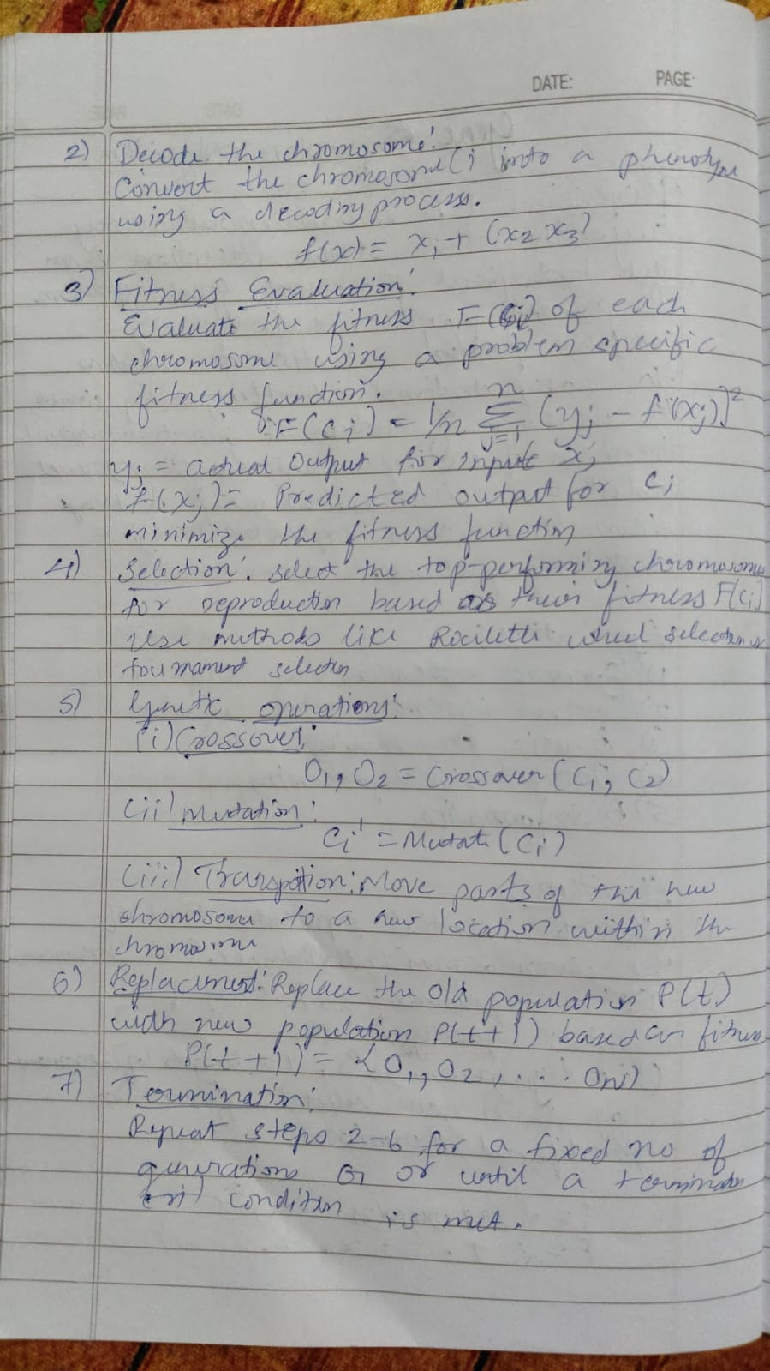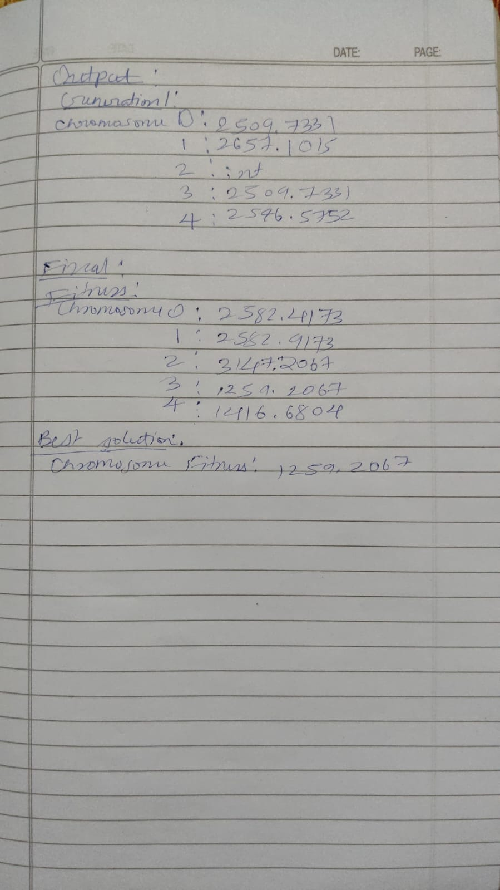

**Code:**

import random

import numpy as np

import operator

# Function set and terminal set

FUNCTIONS = {'+': operator.add, '-': operator.sub, '*': operator.mul, '/': operator.truediv}

TERMINALS = ['x', 1, 2, 3, 4] # x and constants

def random_gene(length=10):

"""Generate a random chromosome (gene)."""

return [random.choice(list(FUNCTIONS.keys()) + TERMINALS) for _ in range(length)]

def decode_chromosome(chromosome, x):

"""Decode chromosome into a functional expression tree (phenotype)."""

stack = []

for gene in chromosome:

if gene in FUNCTIONS: # If it's a function, pop arguments and apply

if len(stack) < 2: # Avoid errors if stack has fewer than 2 elements

stack.append(0)

continue

b = stack.pop()

a = stack.pop()

try:

result = FUNCTIONS[gene](a, b)

except ZeroDivisionError:

result = 1 # Avoid division by zero

stack.append(result)

elif gene == 'x':

stack.append(x)

else:

stack.append(gene)

return stack[0] if stack else 0 # Return top of stack as output

def fitness_function(chromosome, target_function, x_values):

"""Calculate fitness based on Mean Squared Error."""

predictions = [decode_chromosome(chromosome, x) for x in x_values]

targets = [target_function(x) for x in x_values]

mse = np.mean([(p - t) ** 2 for p, t in zip(predictions, targets)])

return mse

def selection(population, fitnesses):

"""Select individuals based on fitness (roulette wheel selection)."""

total_fitness = sum(1 / (f + 1e-6) for f in fitnesses) # Avoid division by zero

probabilities = [(1 / (f + 1e-6)) / total_fitness for f in fitnesses]

return population[np.random.choice(len(population), p=probabilities)]

def mutate(chromosome, mutation_rate=0.1):

"""Apply mutation to a chromosome."""

new_chromosome = chromosome[:]

for i in range(len(new_chromosome)):

if random.random() < mutation_rate:

new_chromosome[i] = random.choice(list(FUNCTIONS.keys()) + TERMINALS)

return new_chromosome

def crossover(parent1, parent2):

"""Perform one-point crossover between two parents."""

point = random.randint(1, len(parent1) - 1)

child1 = parent1[:point] + parent2[point:]

child2 = parent2[:point] + parent1[point:]

return child1, child2

def gene_expression_algorithm(target_function, x_values, population_size=10, generations=20):

"""Main Gene Expression Algorithm."""

# Initialize random population

population = [random_gene() for _ in range(population_size)]

print("Initial Population:")

for i, chrom in enumerate(population):

print(f"Chromosome {i}: {chrom}")

for generation in range(generations):

print(f"\nGeneration {generation + 1}:")

# Calculate fitness for each individual

fitnesses = [fitness_function(chrom, target_function, x_values) for chrom in population]

for i, (chrom, fit) in enumerate(zip(population, fitnesses)):

print(f"Chromosome {i}: {chrom}, Fitness: {fit:.4f}")

# Select the next generation

new_population = []

for _ in range(population_size // 2):

parent1 = selection(population, fitnesses)

parent2 = selection(population, fitnesses)

child1, child2 = crossover(parent1, parent2)

child1 = mutate(child1)

child2 = mutate(child2)

new_population.extend([child1, child2])

population = new_population

# Final results

print("\nFinal Population and Fitness:")

fitnesses = [fitness_function(chrom, target_function, x_values) for chrom in population]

for i, (chrom, fit) in enumerate(zip(population, fitnesses)):

print(f"Chromosome {i}: {chrom}, Fitness: {fit:.4f}")

best_index = np.argmin(fitnesses)

print("\nBest Solution:")

print(f"Chromosome: {population[best_index]}, Fitness: {fitnesses[best_index]:.4f}")

# Target function for regression

def target_function(x):

return x**2 + 2*x + 1 # Example: f(x) = x^2 + 2x + 1

# Input values

x_values = np.linspace(-10, 10, 20)

# Run the algorithm

gene_expression_algorithm(target_function, x_values, population_size=10, generations=10)

**Output:**

